ESN project "Future Schools", Wiesbaden, Germany
January 16, 2017 until January 21, 2017
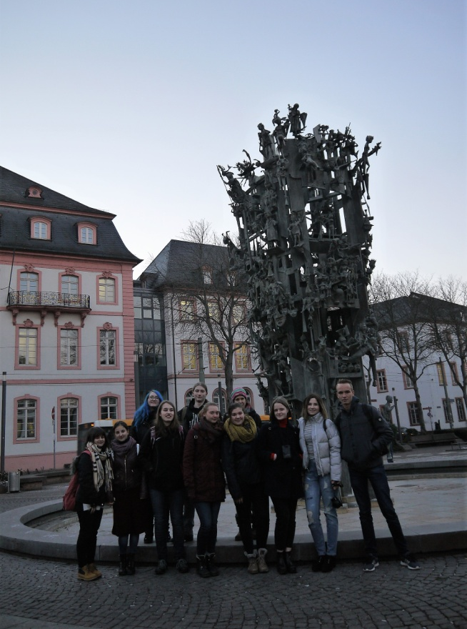
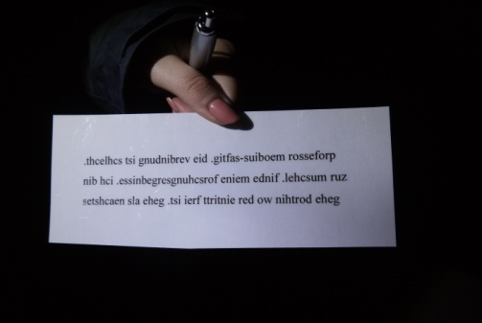
“There's always a good lesson in meeting new people, its enlarging your circle of friends. And though there are times you don't match with their likes, there are some whom you just blend well.” This quote comes from Solita and I can only agree. And in the time from the 16th of January until the 21th of January 2017 our group of eight students had the opportunity to gain this experience. I and three more students of the Carl-von-Ossietzky-Schule (school) were ready to pick up each a pupil so that they were able to stay with us. So it happened that three female Finnish pupils and one French boy followed our invitation to join us during that week. In addition we were not the only students who worked on a project and had no classes. Because all the students worked with their classmates on a topic, so that they could present their results during the open house day, which was on Saturday the 21st of January.

Of course we had to show our outcome related to the issue " Future Schools", too. That was the reason for us to start with a discussion and brainstorming about our topic on Monday. Later at that day we took the bus to Mainz to introduce this old city to them. But also because we wanted to do a game of treasure hunt with them at the University of Mainz, which lead us all across the campus. It was really fun and adventurous, but also a bit problematic for the foreign students to understand the German hints, which we tried to translate into English as far as we could.

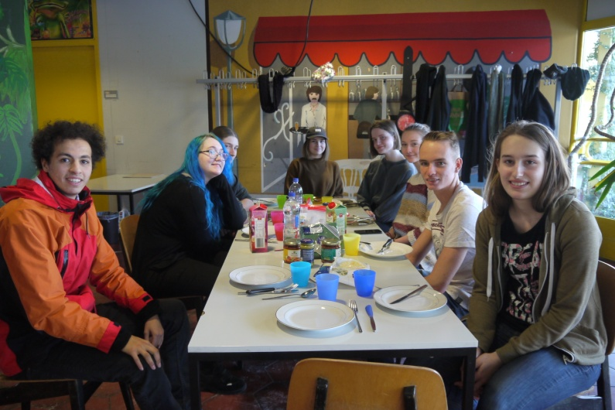
The following days were organized like that day. That means that we worked on the project in the morning until we got hungry and ate lunch together at school. Afterwards we, the students went to different places like to the center of Wiesbaden or to the castle in Biebrich. On Thursday we watched the English version of the movie "Paterson" in the cinema, which was not easy to find because usually most movies are only shown in German. But we were glad that we found that film, so we had that nice and funny evening.
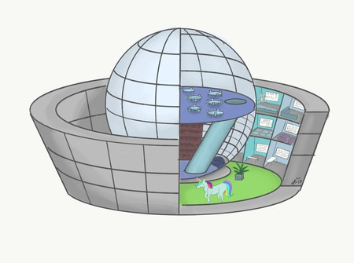
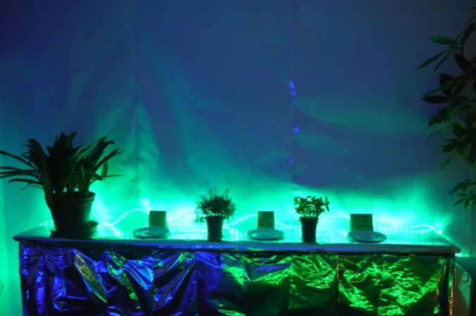
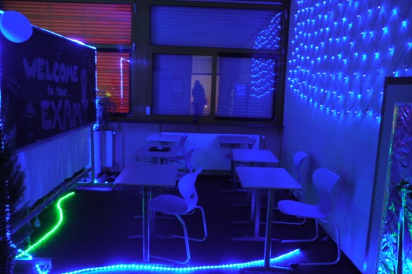
Time was running out and it was already Saturday. We had used our time to change one room of our school into a future classroom like we imagined it. Moreover we used the idea of the treasure hunting game to guide the visitors through our future school. Of course we had a lot more ideas than could be seen in the presentation but not each idea was so realistic that we were able to bring it to life. We also had to make compromises like you can imagine, because of course we did not always like the same ideas. In addition we had to manage all that in a foreign language, which makes it sometimes hard to express your thoughts in an understandable way for the others.
All and all it was a exhausting week but we experienced so many memorable moments, had so much to laugh and understood each other so well that we cannot wait to meet again. And find out if Charles Dickens is speaking the truth:“The pain of parting is nothing to the joy of meeting again.”
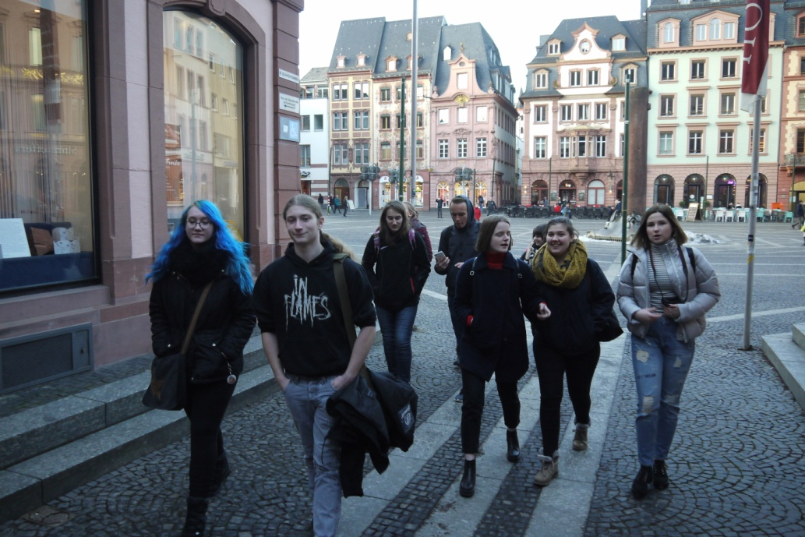

By Lana Hartmann

